Starting a Farm Business
Who is an Entrepreneur?
An Entrepreneur is a person that identifies a need, any need and fills it.
A person that never gives up
A person with no fear of failure
An Entrepreneur takes risk
She doesn’t wait for something to happen. She is the one that makes it happen. She is a visionary, driven by ideas.

Start Small and Think BIG.
Develop ordered steps to follow in order to realize your plan
(Ordered steps that list plans to follow to realize a goal is referred to as an algorithm)
What is an Algorithm?
An algorithm is a step by step method of solving a problem
Let’s illustrate an algorithm to follow in order to make a cup of tea.
- Put the teabag in a cup.
- Fill the kettle with water.
- Boil the water in the kettle.
- Pour some of the boiled water into the cup.
- Add milk to the cup.
- Add sugar to the cup.
- Stir the tea.
- Drink the tea.

Steps Followed are 1-2-3-4-5-6-7-8

If you jump some of the steps, you may end up drinking water instead of Tea.
This can be related to business.
Start from the foundation and build your business. Learn from experience and from those in similar business.

The 8 qualities Successful People have in Common
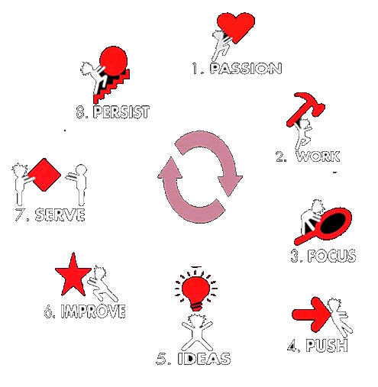
1. Passion is what drives you to do something - no matter what. It's what you love to do. Something that brings out the best in you
2. Work: To be engaged in physical or mental activity in order to achieve a result
3. Focus: the state or quality of having or producing clear visual definition. In business, your focus will be fuel by what you defined as your vision in your business plan.
4. Push: a vigorous effort to do or obtain something. You have to take deliberate actions in order to achieve success in business or in any other venture.
5. Ideas: a thought or suggestion as to a possible course of action. creative ideas will sustain your enterprise and keep you active in the market even in the presence of many competitors
6. Improve: achieve or produce something better than. Innovative is essential to remain active in the market space
7. Serve: perform duties or services for (another person or an organization). Know your customers and serve them right.
8. Persist: continue in an opinion or course of action in spite of difficulty or opposition. "Tough times never last, but tough people do"

